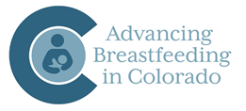


Lactation Friendly Workplace Action Plan

Organization: Date:

Complete this action plan and identify areas you would like to work on using the results of your self-assessment. Each section corresponds with the components of the self-assessment tool.

Policy Development (Commitment)
Action Items | Lead Person | Timeline
Example: create policy, obtain approval from leadership
Resources needed:
Example: sample policy

Time (Workplace Flexibility)
Action Items | Lead Person | Timeline
Example: create policy, ensure time is provided to employees for pumping
Resources needed:
Example: sample policy

Space (Lactation Friendly Environment)
Action Items | Lead Person | Timeline
Example: identify space, purchase items (e.g. chair, table, decor)

Resources needed:
Example: space prioritized for lactation support

Optional: Additional Goals for achieving Lactation Advocate (i.e. Educational Resources, Support Groups, etc.)
Action Items | Lead Person | Timeline
Example: infants allowed at work, insurance plan covers lactation equipment, multi-user pump made available, etc.
Resources needed:

